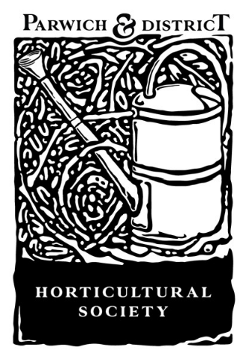
Parwich
Village Show
Memorial Hall
Sunday 13th September 2026

Entries from 10 am to 12 noon on the morning of the show.
Entry fees per item 20p for members, 50p for non-members.
Except where indicated, there is no restriction on the number of entries per person
Judging starts at 12.30
Admission to the public at 2pm

Adults’ and children’s prizes 1st £5, 2nd £2
Trophies and prizes to be presented individually

All items to be collected between 3.30 and 4pm
There will be no auction this year; any items not collected will be disposed of by the committee.

All the following classes are for adults and children aged 12 and over.

PHOTOGRAPHS
McCormick Trophy
for the best entry in this section

Entries must be unframed and no larger than A4 in size.
The photographs may be taken anywhere.

- Something beginning with ‘A’
- Farming life
- Butterflies
- A favourite Parwich spot
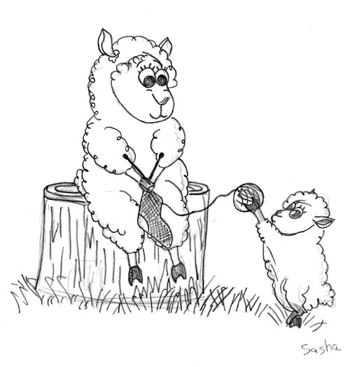
CRAFT
Tarbutt Cup
for the best entry in this section
- A hand-made card from any material
- A Knitted or Crocheted item
- A structure made from bar snacks

POT PLANTS
Ambrose Wilton Trophy
for the best entry in this section

- A pot with Flowering Plant(s)
- One Foliage Plant in a Pot

FLORAL ART
Floral Art Rose Bowl
for the best entry in this section

- An arrangement in an unusual container
- Sporting summer
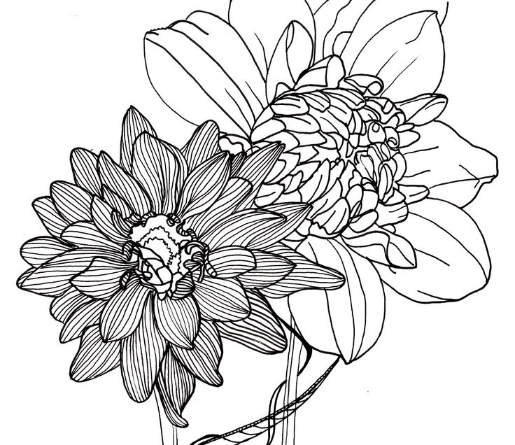 FLOWERS 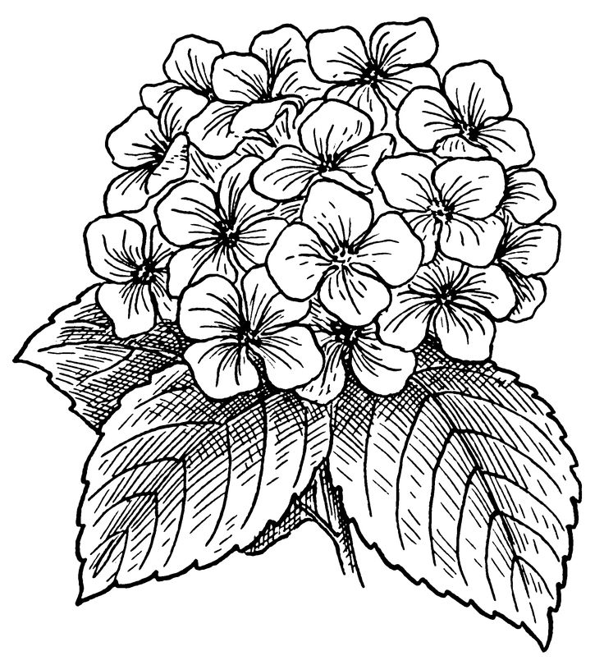

Harry Hopkinson Memorial Cup
for best flower exhibit (classes 12-14)
Alan Oldfield cup
for the best rose (class 15)

12. A bunch of Garden Flowers
13. Bunch of Cut Herbs
14. 1 Seed Head
15. 3 Roses

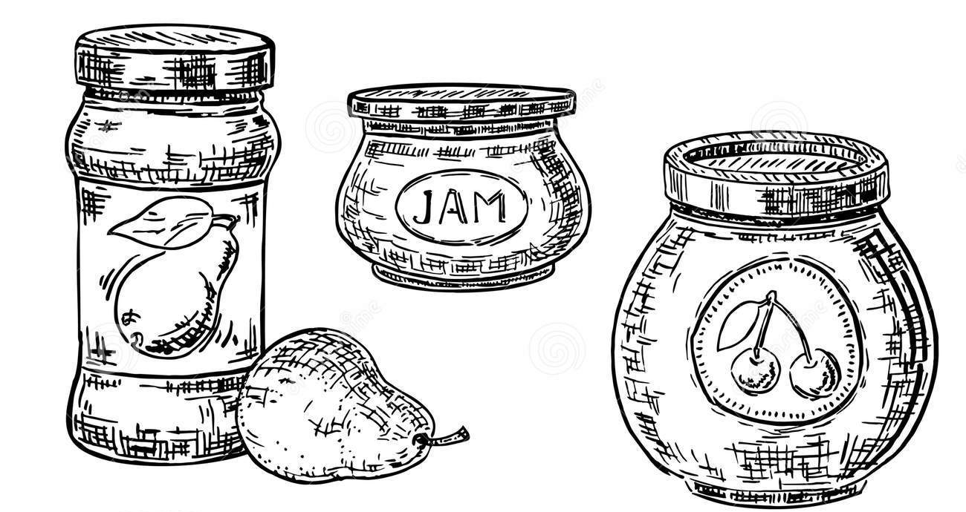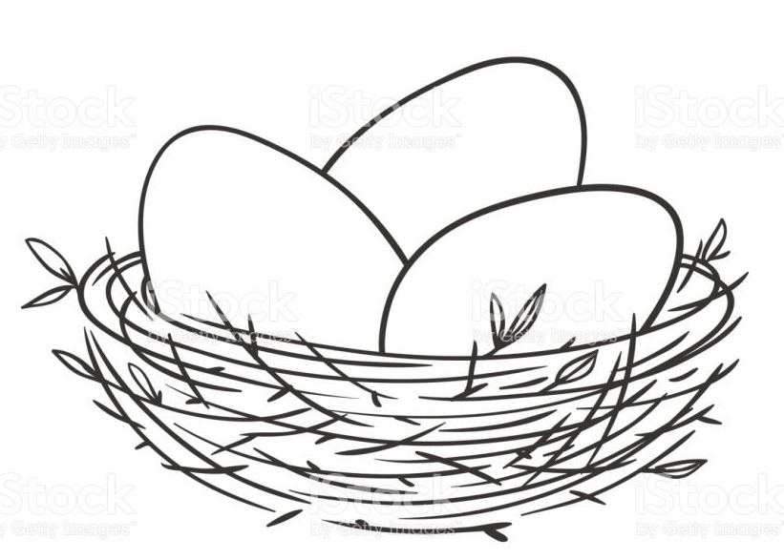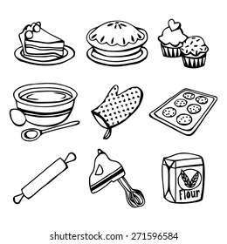
COOKERY AND KITCHEN
Dorothy Foden Cup
for the best entry in classes 17-20
Beasley Cup
For best entry in classes 21-27

Items in this section will be sampled, excluding class 16, and judging will be on appearance and taste.
Only 2 entries per person allowed in each of classes 17-20.

    - 3 eggs of any colour

    - Jar of Jam
    - Jar of Jelly
    - Jar of Marmalade
    - Jar of Chutney or Pickle

    - A fruit loaf, made with any fruit
    - A sponge cake, any style and size
    - A cheesecake
    - An apple pie or flan
    - A quiche
    - 2 sausage rolls
    - Bread loaf or rolls, any style
    - Any Home-made cordial
    - Any home-made alcoholic drink

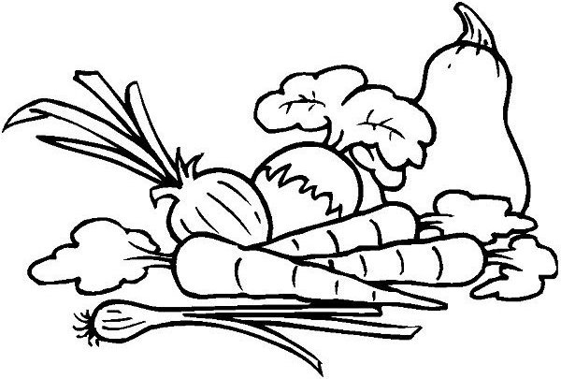 VEGETABLES AND FRUIT
Bob Matthews Tophy
for best vegetable (classes 30-42)
Eric Allsopp Memorial Cup
for best fruit (classes 43-47)

- 3 Beetroot with tops
- 4 Potatoes washed
- Any other root vegetable

- 3 Runner beans
- 3 Beans of any other variety
- The Longest Runner Bean (Only 1 prize in this class)
- 3 Bulbs of Garlic
- 3 Onions, tops shortened
- 3 leeks

- 3 Courgettes
- 1 Cucumber
- 4 Tomatoes with calyx
- Vegetable(s) of any other variety
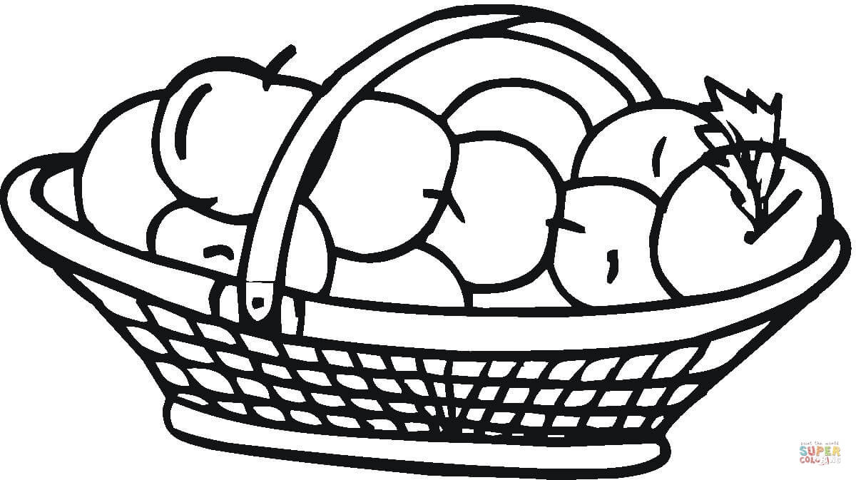
- 3 Eating Apples
- 3 Cooking Apples
- 3 Pears
- 6 Damsons or plums
- A Plate of mixed or single variety Soft Fruit
(Plate up to 20cm diameter)

CHILDREN’S CLASSES
Exhibitors aged 11 yrs or younger – must be their own work

All entries and names of the prize winners from the poster competition “Biodiversity” held during the summer term will also be on display.

Ella Hopkinson Cup for best entry in classes 1-2

A pretty bunch of flowers in a jam jar
- 7 years and under
- 8 – 11 years
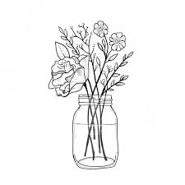
Goldstraw Cup for best photograph in classes 3-5

Photographs by any age on the themes of:
- Something beginning with ‘A’
- Farming life
- Outdoor fun


Tallis Trophy for best entry in classes 6 and 7

A Lego model to your own design (not a set)
6 7 years and under
7 8 – 11 years

Compton-Inglefield Junior Cup for best entry in classes 8 & 9

Something yummy to eat you made at home
8 7 years and under
9 8 – 11 years

Parwich Horticultural Cup for best entry in classes 10 & 11

An awesome animal – made with any fruit or veg
10 7 years and under
11 8 – 11 years
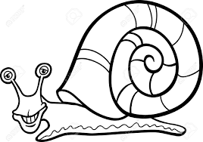

SHOW RULES
  - Entries will only be accepted if made on the official Entry Form – please complete in advance.
  - All vegetables and flowers shown must be grown in the exhibitor's own ground. This rule does not apply to the Floral Art class.
  - The Committee will take every care with each article exhibited, but will not accept any responsibility whatsoever for loss or for damage
  - All prize money will be paid out on the day of the Show.
  - Judges are appointed by the Committee and a judge’s decision is final.
  - Only persons authorized to do so by the Secretary will be allowed to enter the Showroom while judging is taking place.
  - The Committee has the authority to deal with any matter not provided for in these rules.



PARWICH VILLAGE SHOW
Parwich & District Horticultural Society
Entry form – Adult and children 12 and over - Classes 1-47
Please list in class order
Name:

Address:
_________________
_________________

Telephone:
_________________

Total no. Entries:
________________
Total fee:
________________
Class number | No. of entries in class | Fee for each entry | Total fee for each class

PARWICH VILLAGE SHOW
Parwich & District Horticultural Society
Entry form –– Children’s Classes 1-11
Children aged 11yrs or younger, must be their own work.
Please list in class order
Name:

Address:
_________________
_________________

Telephone:
_________________

Total no. Entries:
________________
Total fee:
________________
Class number | No. of entries in class | Fee for each entry | Total fee for each class

